

INFORMATICS INSTITUTE OF TECHNOLOGY

In collaboration with

UNIVERSITY OF WESTMINSTER

Object Oriented Principles

5COSC007C

Coursework – Phase 3

Vehicle Rental System

Module Leader’s Name – Mr. Guhanathan Poravi

Dinuka Piyadigama

UoW ID – 17421047

IIT ID – 2018373

Contents

GUI 2

Code 2

GUIController 12

Code 12

Screenshots 15

Visualize the list of vehicles 15

Filter vehicles by type 17

Filter vehicles by make 18

Check availability on specific dates 19

Book vehicle 21

# GUI

## Code

package lk.dinuka.VehicleRentalSystem.View;

import javafx.application.Application;

import javafx.event.ActionEvent;

import javafx.event.EventHandler;

import javafx.geometry.Insets;

import javafx.scene.Scene;

import javafx.scene.control.*;

import javafx.scene.control.cell.PropertyValueFactory;

import javafx.scene.layout.HBox;

import javafx.scene.layout.VBox;

import javafx.scene.paint.Color;

import javafx.scene.text.Text;

import javafx.stage.Stage;

import lk.dinuka.VehicleRentalSystem.Controller.DatabaseController;

import lk.dinuka.VehicleRentalSystem.Controller.GUIController;

import lk.dinuka.VehicleRentalSystem.Controller.WestminsterRentalVehicleManager;

import lk.dinuka.VehicleRentalSystem.Model.*;

import java.util.ArrayList;

public class GUI extends Application {

public static void main(String[] args) {

launch(args);

}

private static ArrayList<Vehicle> searchedVehicles = new ArrayList<>(); //used to pass in searched vehicles into the table

private static ArrayList<Vehicle> searchInSearch = new ArrayList<>(); //used to filter search by Vehicle type

//-----------------------------------------------------//

@Override

public void start(Stage primaryStage) throws Exception {

// Platform.setImplicitExit(false);

primaryStage.setTitle("List of vehicles in system");

TableView tableOfVehicles = new TableView();

//Creating columns to be added to the table

TableColumn<String, Vehicle> plateNoColumn = new TableColumn<>("Plate No");

plateNoColumn.setCellValueFactory(new PropertyValueFactory<>("plateNo"));

TableColumn<String, Vehicle> makeColumn = new TableColumn<>("Make");

makeColumn.setCellValueFactory(new PropertyValueFactory<>("make"));

TableColumn<String, Vehicle> modelColumn = new TableColumn<>("Model");

modelColumn.setCellValueFactory(new PropertyValueFactory<>("model"));

TableColumn<String, Vehicle> availabilityColumn = new TableColumn<>("Availability");

availabilityColumn.setCellValueFactory(new PropertyValueFactory<>("availability"));

availabilityColumn.setMinWidth(100);

TableColumn<String, Vehicle> engineCapacityColumn = new TableColumn<>("Engine Capacity");

engineCapacityColumn.setCellValueFactory(new PropertyValueFactory<>("engineCapacity"));

engineCapacityColumn.setMinWidth(130);

TableColumn<String, Vehicle> dailyCostColumn = new TableColumn<>("Daily Cost");

dailyCostColumn.setCellValueFactory(new PropertyValueFactory<>("dailyCost"));

dailyCostColumn.setMinWidth(110);

TableColumn<String, Vehicle> typeColumn = new TableColumn<>("Type");

typeColumn.setCellValueFactory(new PropertyValueFactory<>("type"));

TableColumn<String, Vehicle> transmissionColumn = new TableColumn<>("Transmission");

transmissionColumn.setCellValueFactory(new PropertyValueFactory<>("transmission"));

transmissionColumn.setMinWidth(130);

TableColumn<String, Vehicle> hasAirConColumn = new TableColumn<>("Has Air Conditioning");

hasAirConColumn.setCellValueFactory(new PropertyValueFactory<>("hasAirCon"));

hasAirConColumn.setMinWidth(180);

TableColumn<String, Vehicle> startTypeColumn = new TableColumn<>("Start Type");

startTypeColumn.setCellValueFactory(new PropertyValueFactory<>("startType"));

startTypeColumn.setMinWidth(120);

TableColumn<String, Vehicle> wheelSizeColumn = new TableColumn<>("Wheel Size");

wheelSizeColumn.setCellValueFactory(new PropertyValueFactory<>("wheelSize"));

wheelSizeColumn.setMinWidth(130);

tableOfVehicles.getColumns().addAll(plateNoColumn, makeColumn, modelColumn, availabilityColumn, engineCapacityColumn, dailyCostColumn,

typeColumn, transmissionColumn, hasAirConColumn, startTypeColumn, wheelSizeColumn); //adding all the columns to the table

tableOfVehicles.getItems().addAll(WestminsterRentalVehicleManager.getVehiclesInSystem()); //adding all the vehicles in the available

// in the vehiclesInSystem ArrayList

searchedVehicles.addAll(WestminsterRentalVehicleManager.getVehiclesInSystem()); //to get filter by vehicle type to work before searching for a Make

//---------------------------------------------------

HBox searchSection = new HBox();

searchSection.setMinWidth(220);

searchSection.getChildren().add(new Label("Search Make:"));

TextField makeSearch = new TextField();

searchSection.getChildren().add(makeSearch);

Button searchClick = new Button("Search");

searchSection.getChildren().add(searchClick);

Button resetClick = new Button("Reset");

searchSection.getChildren().add(resetClick);

// VBox filterSection = new VBox(new Label("Filter By"));

HBox filterType = new HBox(new Label("Filter Type:"));

Button filterCarClick = new Button("Cars");

filterType.getChildren().add(filterCarClick);

Button filterBikeClick = new Button("Motorbikes");

filterType.getChildren().add(filterBikeClick);

filterType.setPadding(new Insets(10, 0, 0, 0));

// HBox filterEngineCap = new HBox(new Label("Engine Capacity:"));

filterType.setMinWidth(200);

// filterSection.getChildren().addAll(filterType);

VBox allSearchFilter = new VBox(searchSection, filterType);

allSearchFilter.setPadding(new Insets(20, 0, 20, 20));

//---------------------------------------------------

VBox bookingSection = new VBox();

HBox allDates = new HBox();

//pick up date entry section

HBox pickUpDateSec = new HBox(new Label("Pick Up:"));

TextField dayPickUp = new TextField();

TextField monthPickUp = new TextField();

TextField yearPickUp = new TextField();

dayPickUp.setPrefWidth(40);

monthPickUp.setPrefWidth(40);

yearPickUp.setPrefWidth(80);

pickUpDateSec.getChildren().addAll(dayPickUp, monthPickUp, yearPickUp);

//drop off date entry section

HBox dropOffDateSec = new HBox();

Label dropOffLabel = new Label("Drop Off:");

TextField dayDropOff = new TextField();

TextField monthDropOff = new TextField();

TextField yearDropOff = new TextField();

dayDropOff.setPrefWidth(40);

monthDropOff.setPrefWidth(40);

yearDropOff.setPrefWidth(80);

dropOffDateSec.getChildren().addAll(dropOffLabel, dayDropOff, monthDropOff, yearDropOff);

Button availabilityCheck = new Button("Check Availability");

allDates.setSpacing(10.0);

Button bookOnClick = new Button("Book");

// bookOnClick.setAlignment(right);

Text checkBookedStatus = new Text();

Text bookStatusText = new Text();

Text displayTotalCost = new Text();

VBox buttonsForBooking = new VBox();

buttonsForBooking.getChildren().addAll(availabilityCheck, bookOnClick);

buttonsForBooking.setSpacing(5.0);

allDates.getChildren().addAll(pickUpDateSec, dropOffDateSec, buttonsForBooking);

bookingSection.getChildren().addAll(allDates, checkBookedStatus, bookStatusText, displayTotalCost);

bookingSection.setPadding(new Insets(20, 0, 20, 20));

//---------------------------------------------------

VBox parent = new VBox(allSearchFilter, tableOfVehicles, bookingSection);

Scene newScene = new Scene(parent);

primaryStage.setScene(newScene);

primaryStage.show();

primaryStage.setAlwaysOnTop(true); //open the application on top of intelliJ

//---------------//------------------//---------------------//-----------------------//

//Button actions

searchClick.setOnAction(new EventHandler<ActionEvent>() { //actions when search button is clicked

@Override

public void handle(ActionEvent event) {

String vehMakeSearch = makeSearch.getText(); //getting Make to be searched

searchedVehicles.clear(); //clearing previous search results from ArrayList

for (Vehicle searchVeh : WestminsterRentalVehicleManager.getVehiclesInSystem()) {

if (searchVeh.getMake().equals(vehMakeSearch)) {

searchedVehicles.add(searchVeh); //adding vehicles that have matching makes as searched into ArrayList

}

}

// System.out.println(searchedVehicles); //to check

tableOfVehicles.getItems().clear(); //clearing table

tableOfVehicles.getItems().addAll(searchedVehicles);

}

});

resetClick.setOnAction(new EventHandler<ActionEvent>() { //actions when reset button is clicked

@Override

public void handle(ActionEvent event) {

searchedVehicles.clear(); //resetting search to all Vehicles

searchedVehicles.addAll(WestminsterRentalVehicleManager.getVehiclesInSystem());

tableOfVehicles.getItems().clear(); //reseting display to all Vehicles

tableOfVehicles.getItems().addAll(WestminsterRentalVehicleManager.getVehiclesInSystem());

makeSearch.setText("");

}

});

filterCarClick.setOnAction(new EventHandler<ActionEvent>() { //actions when Filter Cars button is clicked

@Override

public void handle(ActionEvent event) {

searchInSearch.clear();

for (Vehicle searchVeh : searchedVehicles) {

if (searchVeh instanceof Car) {

searchInSearch.add(searchVeh); //adding vehicles that are of Type Car into ArrayList

}

}

// System.out.println(searchInSearch); //to check

tableOfVehicles.getItems().clear(); //clearing table

tableOfVehicles.getItems().addAll(searchInSearch);

}

});

filterBikeClick.setOnAction(new EventHandler<ActionEvent>() { //actions when Filter Motorbikes button is clicked

@Override

public void handle(ActionEvent event) {

searchInSearch.clear();

for (Vehicle searchVeh : searchedVehicles) {

if (searchVeh instanceof Motorbike) {

searchInSearch.add(searchVeh); //adding vehicles that are of Type Car into ArrayList

}

}

// System.out.println(searchInSearch); //to check

tableOfVehicles.getItems().clear(); //clearing table

tableOfVehicles.getItems().addAll(searchInSearch);

}

});

//---------------------------------------------------

availabilityCheck.setOnAction(new EventHandler<ActionEvent>() { //actions when Availability check button is clicked

@Override

public void handle(ActionEvent event) {

try {

//getting input of pick up date

Integer dayPickUpInput = Integer.parseInt(dayPickUp.getText()); //getting day

Integer monthPickUpInput = Integer.parseInt(monthPickUp.getText()); //getting month

Integer yearPickUpInput = Integer.parseInt(yearPickUp.getText()); //getting year

//getting input of drop off date

Integer dayDropOffInput = Integer.parseInt(dayDropOff.getText()); //getting day

Integer monthDropOffInput = Integer.parseInt(monthDropOff.getText()); //getting month

Integer yearDropOffInput = Integer.parseInt(yearDropOff.getText()); //getting year

if (tableOfVehicles.getSelectionModel().getSelectedItem() != null) {

Vehicle chosenVeh = (Vehicle) tableOfVehicles.getSelectionModel().getSelectedItem(); //selected vehicle's information

// System.out.println(chosenVeh); //to check whether expected vehicle was chosen

Schedule newBooking = new Schedule(yearPickUpInput, monthPickUpInput, dayPickUpInput,

yearDropOffInput, monthDropOffInput, dayDropOffInput);

boolean availability = GUIController.checkAvailabilityOfVeh(chosenVeh, newBooking);

if (availability) { //vehicle available

checkBookedStatus.setFill(Color.GREEN);

// System.out.println("Vehicle is available for booking.");

checkBookedStatus.setText(chosenVeh.getPlateNo() + " is available for booking.");

} else {

checkBookedStatus.setFill(Color.RED);

// System.out.println("Vehicle isn't available for booking during requested time period.");

checkBookedStatus.setText(chosenVeh.getPlateNo() + " isn't available for booking during requested time period.");

}

} else {

checkBookedStatus.setFill(Color.DARKGRAY);

checkBookedStatus.setText("Please select a vehicle to book.");

}

} catch (NumberFormatException e) {

checkBookedStatus.setFill(Color.DARKGRAY);

checkBookedStatus.setText("Please enter a valid date in Integer Numbers.");

}

}

});

bookOnClick.setOnAction(new EventHandler<ActionEvent>() { //actions when Book button is clicked

@Override

public void handle(ActionEvent event) {

try {

//getting input of pick up date

Integer dayPickUpInput = Integer.parseInt(dayPickUp.getText()); //getting day

Integer monthPickUpInput = Integer.parseInt(monthPickUp.getText()); //getting month

Integer yearPickUpInput = Integer.parseInt(yearPickUp.getText()); //getting year

//getting input of drop off date

Integer dayDropOffInput = Integer.parseInt(dayDropOff.getText()); //getting day

Integer monthDropOffInput = Integer.parseInt(monthDropOff.getText()); //getting month

Integer yearDropOffInput = Integer.parseInt(yearDropOff.getText()); //getting year

if (tableOfVehicles.getSelectionModel().getSelectedItem() != null) {

//getting selected vehicle's information

Vehicle chosenVeh = (Vehicle) tableOfVehicles.getSelectionModel().getSelectedItem(); //selected vehicle's information

//down-casted from Object type to Vehicle type

System.out.println(chosenVeh); //to check whether expected vehicle was chosen

Schedule newBooking = new Schedule(yearPickUpInput, monthPickUpInput, dayPickUpInput,

yearDropOffInput, monthDropOffInput, dayDropOffInput);

boolean booked = GUIController.createBooking(chosenVeh, newBooking);

if (booked) {

checkBookedStatus.setFill(Color.GREEN);

// System.out.println("Vehicle is available for booking.");

checkBookedStatus.setText(chosenVeh.getPlateNo() + " is available for booking.");

bookStatusText.setText("Booked vehicle with Plate No: " + chosenVeh.getPlateNo() + " from " +

newBooking.getPickUp() + " to " + newBooking.getDropOff());

//addToBookedDB here

DatabaseController.addToBookedDB(chosenVeh.getPlateNo(), yearPickUpInput, monthPickUpInput, dayPickUpInput,

yearDropOffInput, monthDropOffInput, dayDropOffInput);

displayTotalCost.setText("Total Cost: $" + GUIController.getCalculatedRent(chosenVeh.getDailyCost(), newBooking));

} else {

//notify the user that the vehicle isn't available for rent during the chosen time period.

checkBookedStatus.setFill(Color.RED);

// System.out.println("Vehicle isn't available for booking during requested time period.");

checkBookedStatus.setText(chosenVeh.getPlateNo() + " isn't available for booking during requested time period.");

}

} else {

checkBookedStatus.setFill(Color.DARKGRAY);

checkBookedStatus.setText("Please select a vehicle to book.");

}

} catch (NumberFormatException e) {

checkBookedStatus.setFill(Color.DARKGRAY);

checkBookedStatus.setText("Please enter a valid date in Integer Numbers.");

}

}

});

}

}

/*

References:

https://stackoverflow.com/questions/14169240/getting-integer-values-from-textfield

How to get information of selected row in javafx tableview

https://stackoverflow.com/questions/17388866/getting-selected-item-from-a-javafx-tableview

*/

# GUIController

## Code

package lk.dinuka.VehicleRentalSystem.Controller;

import lk.dinuka.VehicleRentalSystem.Model.Schedule;

import lk.dinuka.VehicleRentalSystem.Model.Vehicle;

import java.math.BigDecimal;

import java.time.LocalDate;

import java.time.Period;

import java.util.ArrayList;

import java.util.List;

import static lk.dinuka.VehicleRentalSystem.Controller.WestminsterRentalVehicleManager.bookedVehicles;

public class GUIController {

public static boolean createBooking(Vehicle chosenVeh, Schedule newBooking ) {

//used to create a booking as required and add booking info into the system

List<Schedule> bookedVehicleDates = new ArrayList<>(); //used to record pick up & drop off dates of a vehicle

//Only used to store the dates into the bookedVehicles HashMap

boolean availability = checkAvailabilityOfVeh(chosenVeh, newBooking); //checking whether vehicle is available for booking

System.out.println();

System.out.println("---checked availability---");

System.out.println();

if (availability) {

System.out.println("Vehicle is available for booking");

if (bookedVehicles.containsKey(chosenVeh.getPlateNo())) {

bookedVehicleDates = bookedVehicles.get(chosenVeh.getPlateNo()); //getting recorded bookings into temporary list

}

bookedVehicleDates.add(newBooking); //adding the newly booked dates to the list of bookings.

WestminsterRentalVehicleManager.bookedVehicles.put(chosenVeh.getPlateNo(), (ArrayList) bookedVehicleDates); //adding all booked vehicles to bookedVehicles HashMap

System.out.println(WestminsterRentalVehicleManager.bookedVehicles); //checking whether required booking was entered into the system

return true;

} else {

System.out.println("Vehicle isn't available for booking during the requested time period.");

//vehicle isn't available to be book

return false;

}

}

//``````~~~~~~~~~~~~~~~~~~~``````

public static boolean checkAvailabilityOfVeh(Vehicle chosenVeh, Schedule newBooking ) {

//used to check for the availability of a chosen vehicle

String plateNoOfChosen = chosenVeh.getPlateNo(); //The plate number of the chosen vehicle

if (!WestminsterRentalVehicleManager.bookedVehicles.containsKey(plateNoOfChosen)) {

return true; //vehicle is not booked

} else {

List<Schedule> bookedVehicleDates = new ArrayList<>(); //used to record pick up & drop off dates of a vehicle

bookedVehicleDates = bookedVehicles.get(chosenVeh.getPlateNo()); //getting recorded bookings into temporary list

//Only used to get each of the dates from the bookedVehicles HashMap Values

int totalBookings = bookedVehicles.get(plateNoOfChosen).size();

int passedChecks = 0;

for (int i = 0; i < totalBookings; i++) {

boolean checkPickUpBefore = LocalDate.from(newBooking.getPickUp()).isBefore( //pick up before booked pickup

bookedVehicleDates.get(i).getPickUp());

boolean checkDropOffBefore = LocalDate.from(newBooking.getDropOff()).isBefore( //drop off before booked pick up

bookedVehicleDates.get(i).getPickUp());

boolean checkPickUpAfter = LocalDate.from(newBooking.getPickUp()).isAfter( //pick up after booked drop off

bookedVehicleDates.get(i).getDropOff());

boolean checkDropOffAfter = LocalDate.from(newBooking.getDropOff()).isAfter( //drop off after booked drop off

bookedVehicleDates.get(i).getDropOff());

if ((checkPickUpBefore && checkDropOffBefore) || (checkPickUpAfter && checkDropOffAfter)) {

// if both requested pick up and drop off are either before the booked pick up date or after the

// booked drop off date, the vehicle is available for requested period

passedChecks += 1;

}

//if false for at least one, can't book

}

//-------------------

// if (totalBookings>0){

// return passedChecks == totalBookings; //if all the bookings don't interfere with the requested time -> true

//

// } else{

// return true;

//since this else block will run only if there has been at least one previous entry, the above verification isn't required

return passedChecks == totalBookings; //if all the bookings don't interfere with the requested time -> true

}

}

public static BigDecimal getCalculatedRent(BigDecimal dailyCost, Schedule newBooking) {

// have calculation of total cost here

BigDecimal totalCost = BigDecimal.valueOf(0);

Period period = Period.between(newBooking.getPickUp(),newBooking.getDropOff());//difference between the number of days

int noOfDays = period.getDays();

if (noOfDays > 0) {

return dailyCost.multiply(BigDecimal.valueOf(noOfDays)); //dailyCost*noOfDays

}

return totalCost;

}

}

# Screenshots

### Visualize the list of vehicles

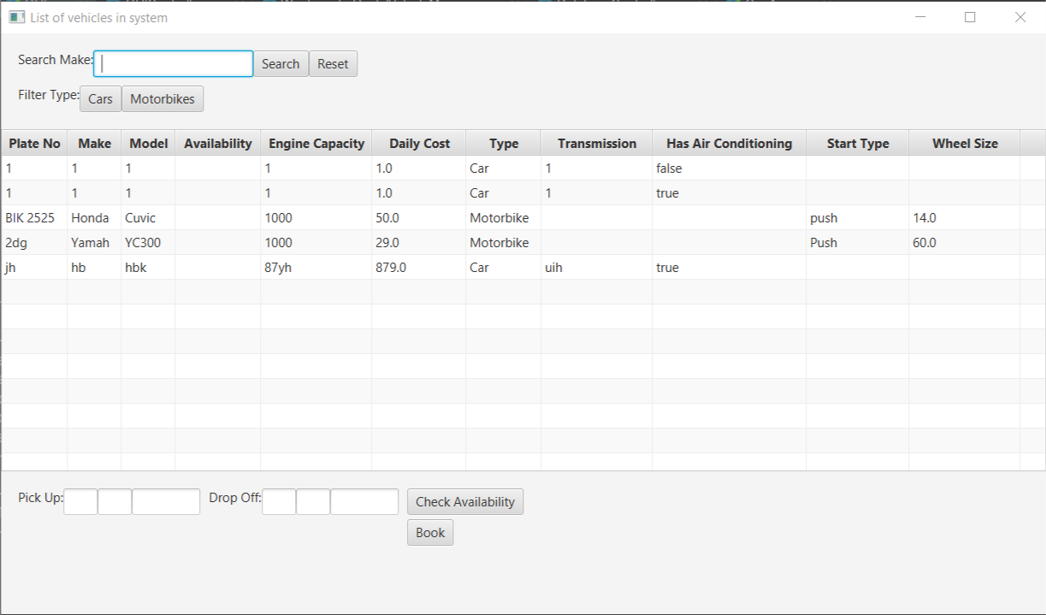

##### Code

@Override

public void start(Stage primaryStage) throws Exception {

// Platform.setImplicitExit(false);

primaryStage.setTitle("List of vehicles in system");

TableView tableOfVehicles = new TableView();

//Creating columns to be added to the table

TableColumn<String, Vehicle> plateNoColumn = new TableColumn<>("Plate No");

plateNoColumn.setCellValueFactory(new PropertyValueFactory<>("plateNo"));

TableColumn<String, Vehicle> makeColumn = new TableColumn<>("Make");

makeColumn.setCellValueFactory(new PropertyValueFactory<>("make"));

TableColumn<String, Vehicle> modelColumn = new TableColumn<>("Model");

modelColumn.setCellValueFactory(new PropertyValueFactory<>("model"));

TableColumn<String, Vehicle> availabilityColumn = new TableColumn<>("Availability");

availabilityColumn.setCellValueFactory(new PropertyValueFactory<>("availability"));

availabilityColumn.setMinWidth(100);

TableColumn<String, Vehicle> engineCapacityColumn = new TableColumn<>("Engine Capacity");

engineCapacityColumn.setCellValueFactory(new PropertyValueFactory<>("engineCapacity"));

engineCapacityColumn.setMinWidth(130);

TableColumn<String, Vehicle> dailyCostColumn = new TableColumn<>("Daily Cost");

dailyCostColumn.setCellValueFactory(new PropertyValueFactory<>("dailyCost"));

dailyCostColumn.setMinWidth(110);

TableColumn<String, Vehicle> typeColumn = new TableColumn<>("Type");

typeColumn.setCellValueFactory(new PropertyValueFactory<>("type"));

TableColumn<String, Vehicle> transmissionColumn = new TableColumn<>("Transmission");

transmissionColumn.setCellValueFactory(new PropertyValueFactory<>("transmission"));

transmissionColumn.setMinWidth(130);

TableColumn<String, Vehicle> hasAirConColumn = new TableColumn<>("Has Air Conditioning");

hasAirConColumn.setCellValueFactory(new PropertyValueFactory<>("hasAirCon"));

hasAirConColumn.setMinWidth(180);

TableColumn<String, Vehicle> startTypeColumn = new TableColumn<>("Start Type");

startTypeColumn.setCellValueFactory(new PropertyValueFactory<>("startType"));

startTypeColumn.setMinWidth(120);

TableColumn<String, Vehicle> wheelSizeColumn = new TableColumn<>("Wheel Size");

wheelSizeColumn.setCellValueFactory(new PropertyValueFactory<>("wheelSize"));

wheelSizeColumn.setMinWidth(130);

tableOfVehicles.getColumns().addAll(plateNoColumn, makeColumn, modelColumn, availabilityColumn, engineCapacityColumn, dailyCostColumn,

typeColumn, transmissionColumn, hasAirConColumn, startTypeColumn, wheelSizeColumn); //adding all the columns to the table

tableOfVehicles.getItems().addAll(WestminsterRentalVehicleManager.getVehiclesInSystem()); //adding all the vehicles in the available

// in the vehiclesInSystem ArrayList

searchedVehicles.addAll(WestminsterRentalVehicleManager.getVehiclesInSystem()); //to get filter by vehicle type to work before searching for a Make

##### Explanation of the functionality

When the GUI is opened, the list of all vehicles is displayed as shown above.

### Filter vehicles by type

#### Filtered by cars

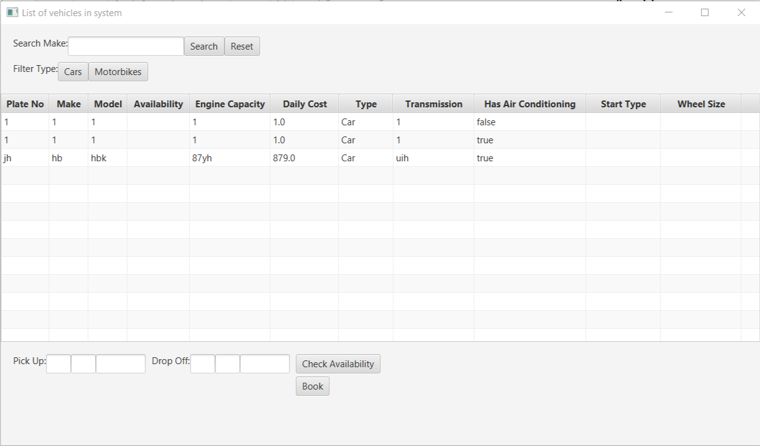

##### Code

filterCarClick.setOnAction(new EventHandler<ActionEvent>() { //actions when Filter Cars button is clicked

@Override

public void handle(ActionEvent event) {

searchInSearch.clear();

for (Vehicle searchVeh : searchedVehicles) {

if (searchVeh instanceof Car) {

searchInSearch.add(searchVeh); //adding vehicles that are of Type Car into ArrayList

}

}

// System.out.println(searchInSearch); //to check

tableOfVehicles.getItems().clear(); //clearing table

tableOfVehicles.getItems().addAll(searchInSearch);

}

});

filterBikeClick.setOnAction(new EventHandler<ActionEvent>() { //actions when Filter Motorbikes button is clicked

@Override

public void handle(ActionEvent event) {

searchInSearch.clear();

for (Vehicle searchVeh : searchedVehicles) {

if (searchVeh instanceof Motorbike) {

searchInSearch.add(searchVeh); //adding vehicles that are of Type Car into ArrayList

}

}

// System.out.println(searchInSearch); //to check

tableOfVehicles.getItems().clear(); //clearing table

tableOfVehicles.getItems().addAll(searchInSearch);

}

});

##### Explanation of the functionality

When the “Filter Type: Cars” button is clicked, all the cars in the system are displayed in the table. Similarly, it works for Motorbikes as well.

### Filter vehicles by make

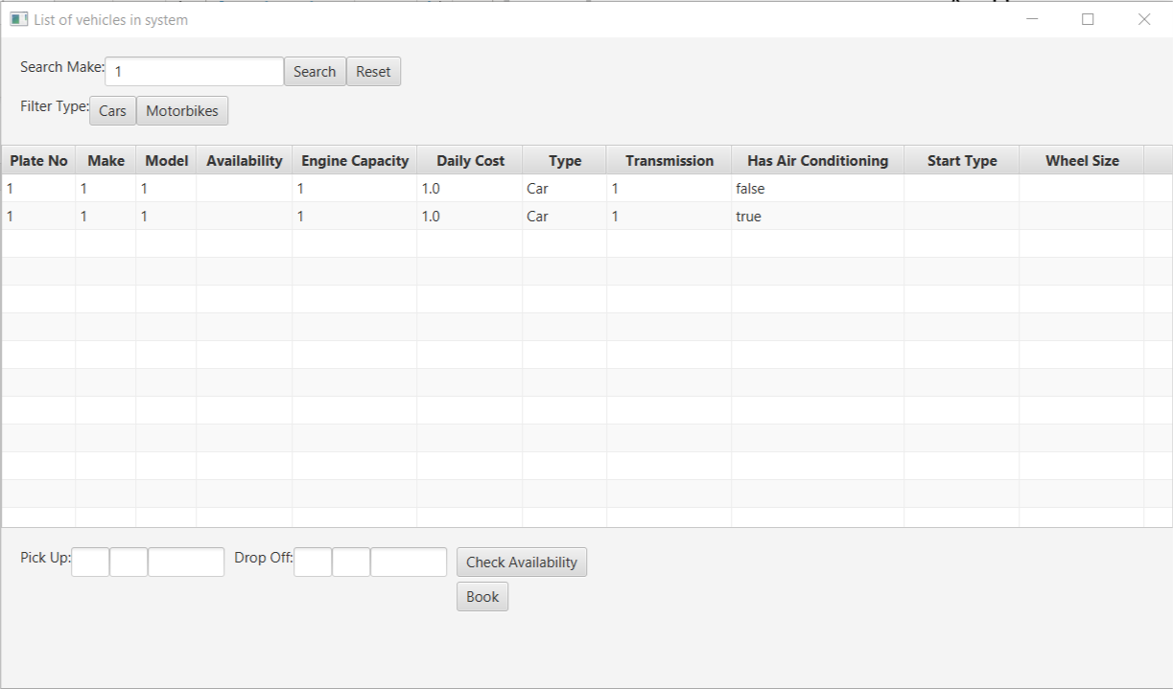

##### Code

searchClick.setOnAction(new EventHandler<ActionEvent>() { //actions when search button is clicked

@Override

public void handle(ActionEvent event) {

String vehMakeSearch = makeSearch.getText(); //getting Make to be searched

searchedVehicles.clear(); //clearing previous search results from ArrayList

for (Vehicle searchVeh : WestminsterRentalVehicleManager.getVehiclesInSystem()) {

if (searchVeh.getMake().equals(vehMakeSearch)) {

searchedVehicles.add(searchVeh); //adding vehicles that have matching makes as searched into ArrayList

}

}

// System.out.println(searchedVehicles); //to check

tableOfVehicles.getItems().clear(); //clearing table

tableOfVehicles.getItems().addAll(searchedVehicles);

}

});

##### Explanation of the functionality

When the required make is typed in and search using the search box, all vehicles related to the searched Make is displayed.

When researched is clicked all Filters and search results are removed, displaying all the vehicles available in the system.

### Check availability on specific dates

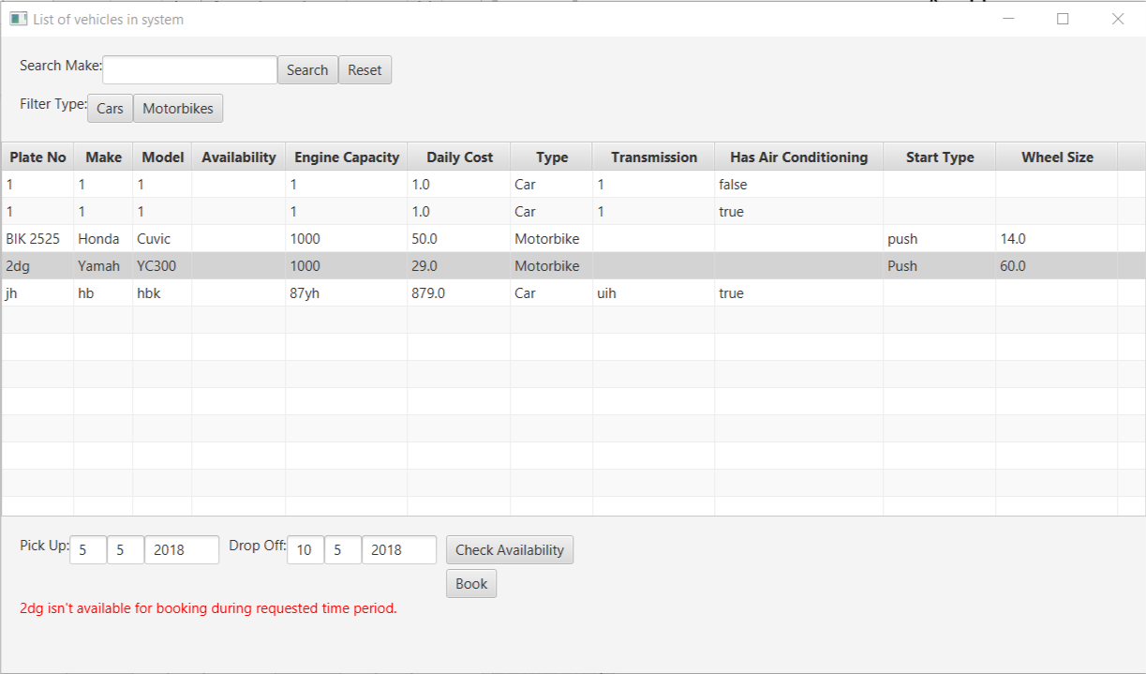

##### Code

availabilityCheck.setOnAction(new EventHandler<ActionEvent>() { //actions when Availability check button is clicked

@Override

public void handle(ActionEvent event) {

try {

//getting input of pick up date

Integer dayPickUpInput = Integer.parseInt(dayPickUp.getText()); //getting day

Integer monthPickUpInput = Integer.parseInt(monthPickUp.getText()); //getting month

Integer yearPickUpInput = Integer.parseInt(yearPickUp.getText()); //getting year

//getting input of drop off date

Integer dayDropOffInput = Integer.parseInt(dayDropOff.getText()); //getting day

Integer monthDropOffInput = Integer.parseInt(monthDropOff.getText()); //getting month

Integer yearDropOffInput = Integer.parseInt(yearDropOff.getText()); //getting year

if (tableOfVehicles.getSelectionModel().getSelectedItem() != null) {

Vehicle chosenVeh = (Vehicle) tableOfVehicles.getSelectionModel().getSelectedItem(); //selected vehicle's information

// System.out.println(chosenVeh); //to check whether expected vehicle was chosen

Schedule newBooking = new Schedule(yearPickUpInput, monthPickUpInput, dayPickUpInput,

yearDropOffInput, monthDropOffInput, dayDropOffInput);

boolean availability = GUIController.checkAvailabilityOfVeh(chosenVeh, newBooking);

if (availability) { //vehicle available

checkBookedStatus.setFill(Color.GREEN);

// System.out.println("Vehicle is available for booking.");

checkBookedStatus.setText(chosenVeh.getPlateNo() + " is available for booking.");

} else {

checkBookedStatus.setFill(Color.RED);

// System.out.println("Vehicle isn't available for booking during requested time period.");

checkBookedStatus.setText(chosenVeh.getPlateNo() + " isn't available for booking during requested time period.");

}

} else {

checkBookedStatus.setFill(Color.DARKGRAY);

checkBookedStatus.setText("Please select a vehicle to book.");

}

} catch (NumberFormatException e) {

checkBookedStatus.setFill(Color.DARKGRAY);

checkBookedStatus.setText("Please enter a valid date in Integer Numbers.");

}

}

});

##### Explanation of the functionality

When “Check Availability” is clicked after a vehicle is selected and pick up & drop off dates are specified, the system will let the user know whether the chosen vehicles is available or not during the requested time period.

### Book vehicle

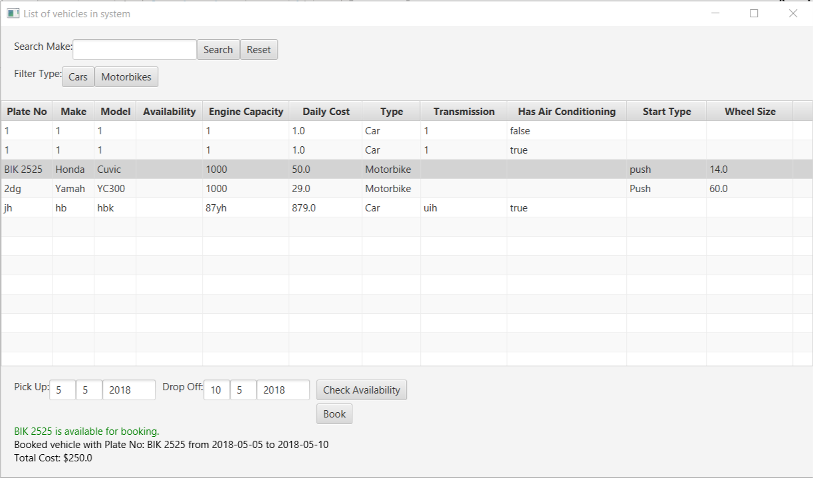

##### Code

bookOnClick.setOnAction(new EventHandler<ActionEvent>() { //actions when Book button is clicked

@Override

public void handle(ActionEvent event) {

try {

//getting input of pick up date

Integer dayPickUpInput = Integer.parseInt(dayPickUp.getText()); //getting day

Integer monthPickUpInput = Integer.parseInt(monthPickUp.getText()); //getting month

Integer yearPickUpInput = Integer.parseInt(yearPickUp.getText()); //getting year

//getting input of drop off date

Integer dayDropOffInput = Integer.parseInt(dayDropOff.getText()); //getting day

Integer monthDropOffInput = Integer.parseInt(monthDropOff.getText()); //getting month

Integer yearDropOffInput = Integer.parseInt(yearDropOff.getText()); //getting year

if (tableOfVehicles.getSelectionModel().getSelectedItem() != null) {

//getting selected vehicle's information

Vehicle chosenVeh = (Vehicle) tableOfVehicles.getSelectionModel().getSelectedItem(); //selected vehicle's information

//down-casted from Object type to Vehicle type

System.out.println(chosenVeh); //to check whether expected vehicle was chosen

Schedule newBooking = new Schedule(yearPickUpInput, monthPickUpInput, dayPickUpInput,

yearDropOffInput, monthDropOffInput, dayDropOffInput);

boolean booked = GUIController.createBooking(chosenVeh, newBooking);

if (booked) {

checkBookedStatus.setFill(Color.GREEN);

// System.out.println("Vehicle is available for booking.");

checkBookedStatus.setText(chosenVeh.getPlateNo() + " is available for booking.");

bookStatusText.setText("Booked vehicle with Plate No: " + chosenVeh.getPlateNo() + " from " +

newBooking.getPickUp() + " to " + newBooking.getDropOff());

//addToBookedDB here

DatabaseController.addToBookedDB(chosenVeh.getPlateNo(), yearPickUpInput, monthPickUpInput, dayPickUpInput,

yearDropOffInput, monthDropOffInput, dayDropOffInput);

displayTotalCost.setText("Total Cost: $" + GUIController.getCalculatedRent(chosenVeh.getDailyCost(), newBooking));

} else {

//notify the user that the vehicle isn't available for rent during the chosen time period.

checkBookedStatus.setFill(Color.RED);

// System.out.println("Vehicle isn't available for booking during requested time period.");

checkBookedStatus.setText(chosenVeh.getPlateNo() + " isn't available for booking during requested time period.");

}

} else {

checkBookedStatus.setFill(Color.DARKGRAY);

checkBookedStatus.setText("Please select a vehicle to book.");

}

} catch (NumberFormatException e) {

checkBookedStatus.setFill(Color.DARKGRAY);

checkBookedStatus.setText("Please enter a valid date in Integer Numbers.");

}

}

});

##### Explanation of the functionality

When ‘Book’ button is clicked, the system will perform a similar check like “Check Availability” and let the user know that the vehicle was booked for the requested time period.

The total cost will also be displayed below.